**Mystery over 71-year-old Forth bridge plans**

* 29 September 2016
* From the section [Edinburgh, Fife & East Scotland](http://www.bbc.co.uk/news/scotland/edinburgh_east_and_fife)

<http://www.bbc.co.uk/news/uk-scotland-edinburgh-east-fife-37506251>

**The public is being urged to help solve a mystery involving plans for a second rail bridge over the Firth of Forth.**

Two drawings, dating back to 1945, were discovered in an old box file hidden under a desk in Glasgow. But they only came to light recently.

The second rail bridge would have been built downstream of the existing bridge and very close by.

Historians are investigating theories about why the designs were drawn up but are keen to know why they were dropped.

Network Rail has commissioned an artist's impression of what the fourth Forth Bridge would have looked like and where it would have been situated.

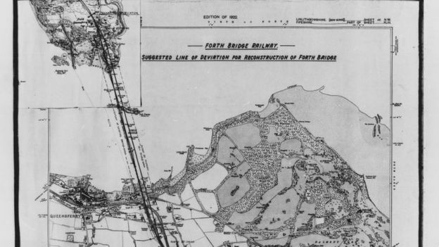

**The public is being urged to help solve a mystery involving plans for a second rail bridge over the Firth of Forth.**

Two drawings, dating back to 1945, were discovered in an old box file hidden under a desk in Glasgow. But they only came to light recently.

The second rail bridge would have been built downstream of the existing bridge and very close by.

Historians are investigating theories about why the designs were drawn up but are keen to know why they were dropped.

Network Rail has commissioned an artist's impression of what the fourth Forth Bridge would have looked like and where it would have been situated.

Image copyright Network Rail

Vicky Stretch, Network Rail archivist, said: "We have a lot of drawings for the Forth Bridge but very much concentrating on the original construction of the bridge we see today.

So this is a real mystery and why these drawings were created we just don't know."

Dr Miles Oglethorpe, of Historic Environment Scotland, speculated that the plans were to replace a bridge damaged in war or to cope with increased demand for trains.

He said: "It's possible it was in anticipation of potential damage through enemy action.

"Although they date from 1945, that was the time the V bombs were landing in London and there was a possibility that they were thinking it might be replaced.

"But my theory is simply that they were anticipating more rail travel.

"The existing bridge was being very heavily used and they were thinking ahead."

The Forth Bridge is a world heritage site.

Anyone with information should contact [**Network Rail**](http://www.forthbridgeexperience.com/contact-us/).